Strings, StringBuffer, and StringBuilder

1. String in Java
- Definition: A String in Java is an object that represents a sequence of characters. Strings are immutable, meaning once created, their value cannot be changed.
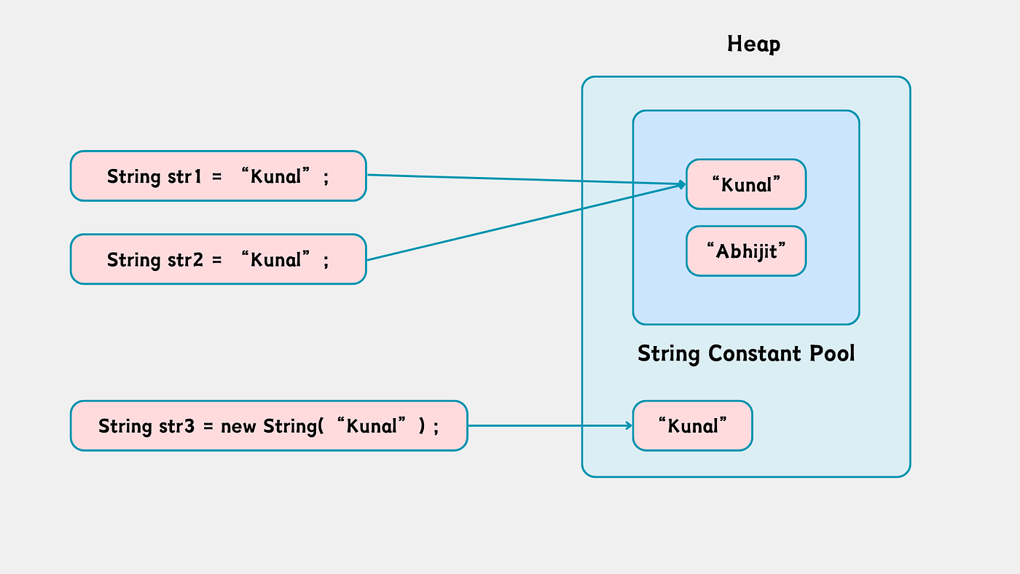
- Declaration and Initialization:
// Using string literal
String str1 = "Hello";

// Using new keyword
String str2 = new String("World");
- Important Methods of String:
length() - Returns the length of the string
charAt(int index) - Returns the character at specified index
concat(String str)- Concatenates specified string
substring(int beginIndex, int endIndex) - Extracts substring
equals(String str) - Compares two strings for content equality
equalsIgnoreCase(String str) - Compares ignoring case
toUpperCase() - Converts string to uppercase
toLowerCase() - Converts string to lowercase
trim() - Removes leading and trailing spaces
replace(char oldChar, char newChar) - Replaces character

- Example:
String name = "Vikram";
System.out.println(name.length()); // 6
System.out.println(name.charAt(0)); // 'V'
System.out.println(name.toUpperCase()); // "VIKRAM"
- Important Points:
  - Strings are stored in a String Pool for memory optimization.
  - Immutable: Any operation that changes the string creates a new string object.

2. StringBuffer in Java
- Definition: StringBuffer is a mutable sequence of characters, meaning it can be changed after creation. It is thread-safe (synchronized).
- Declaration and Initialization:
StringBuffer sb = new StringBuffer("Hello");
Important Methods:
append(String str) - Adds the specified string at the end
insert(int offset, String str) - Inserts string at specified position
replace(int start, int end, String str) - Replaces substring from start to end.
delete(int start, int end) - Deletes substring from start to end
reverse() - Reverses the sequence of characters
capacity() - Returns the current capacity of the buffer
charAt(int index) - Returns character at specified index
setCharAt(int index, char ch) - Modifies character at specified index
- Example:
StringBuffer sb = new StringBuffer("Vikram");
sb.append(" R");
System.out.println(sb); // "Vikram R"
sb.insert(6, " Kumar");
System.out.println(sb); // "Vikram Kumar R"
sb.reverse();
System.out.println(sb); // "R ramuK markiV"
- Important Points:
  - Thread-safe → Safe for multi-threaded operations.
  - Mutable → No new object is created on modification.
  - Default capacity = 16 + length of string.

3. StringBuilder in Java
- Definition: StringBuilder is similar to StringBuffer but not thread-safe. It is also mutable and faster than StringBuffer because it is unsynchronized.
- Declaration and Initialization:
StringBuilder sb = new StringBuilder("Hello");
- Important Methods:
(Same as StringBuffer: append, insert, delete, replace, reverse, etc.)
- Example:
StringBuilder sb = new StringBuilder("Vikram");
sb.append(" R");
System.out.println(sb); // "Vikram R"
sb.reverse();
System.out.println(sb); // "R mar kiV"
- Important Points:
  - Faster than StringBuffer because it is non-synchronized.
  - Ideal for single-threaded operations.
  - Mutable → Efficient for string manipulation in loops.

4. Comparison Table: String vs StringBuffer vs StringBuilder
Feature | String | StringBuffer | StringBuilder
Mutability | Immutable | Mutable | Mutable
Thread-safe | No | Yes | No
Performance | Slower (for modification) | Slower than StringBuilder (thread-safe) | Faster
Methods | Many (substring, concat, etc.) | Many (append, insert, delete, reverse) | Many (same as StringBuffer)
Use Case | Fixed string content | Multi-threaded mutable strings | Single-threaded mutable strings

